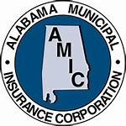Coronavirus (Covid-19) Personnel Protection for Law Enforcement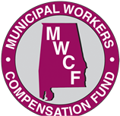

Training Prepared by:
The Alabama Municipal Insurance Corporation
and the Municipal Workers Compensation Fund
Loss Control Division

This is to certify that

Employee Name

has successfully completed a one-hour Inservice Training Session on Police Coronavirus

(Covid-19) Personnel Protection Standard Operating Procedures

_____ _____, 2020 City, AL

____________________________/_______________________
Instructor Signature Department

_________________________________________
Attending Officer’s Signature

